OPERATING SYSTEMS
PRACTICAL ASSIGNMENT
OS Tour • Processes & Threads • CPU Scheduling
Detail | Entry
Name | Rani kumari
Roll Number | B25BS1270
Section | COHORT 3
Date | 20 SEPTEMBER 2026

Section A - Intro to Operating Systems & Role

Q1. OS Tour using copy.sh and Google Colab
(a) Virtual OS running in copy.sh
Screenshot Q1(a) - Virtual Linux OS running in copy.sh
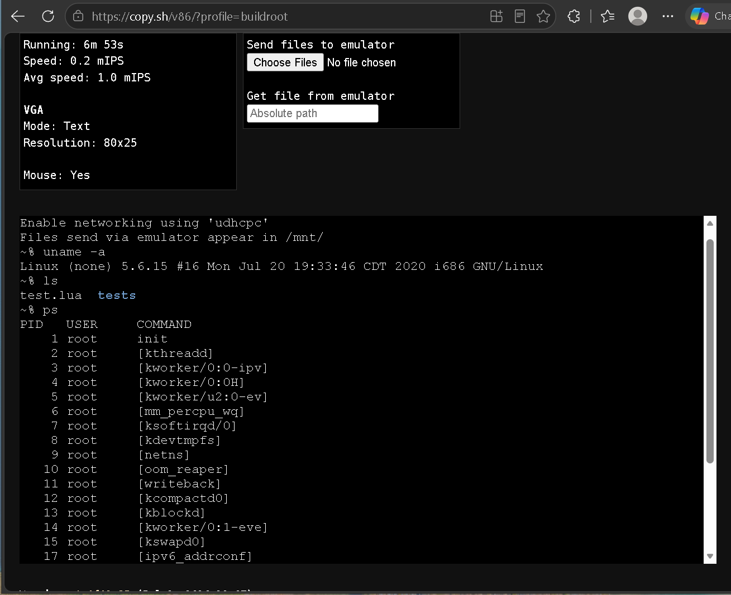
Observation: The copy.sh environment provides a virtual Linux operating system with a shell/terminal. The system initializes a kernel and provides access to processes, files, and system commands. I used commands such as uname -a (which showed Linux 5.6.15 i686), ls (which listed test.lua and tests) and ps (which listed processes such as init and kernel threads) to interact with the operating system.
(b) Active Google Colab notebook
Screenshot Q1(b) - Active notebook in Google Colab
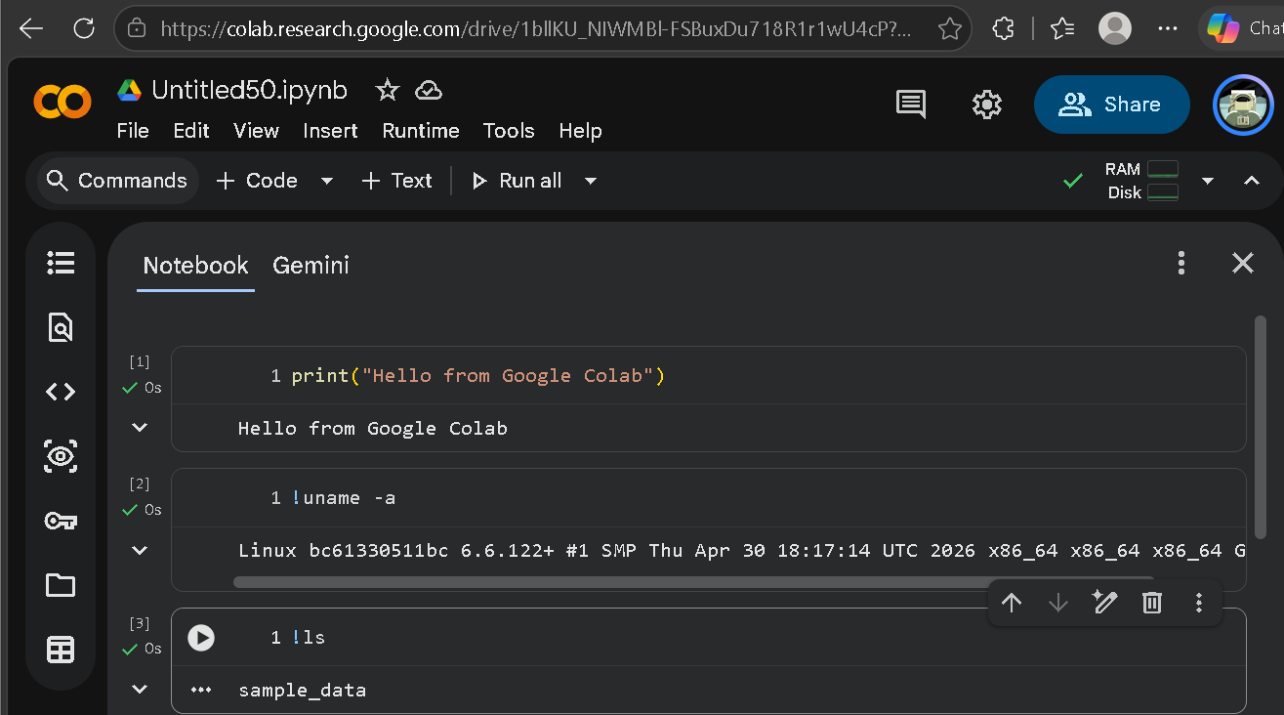
Observation: In Colab I ran a print statement, !uname -a and !ls. The output showed Linux 6.6.122+ (x86_64) and a sample_data folder. This confirms that my Python code is not running on my own laptop but inside a remote Linux-based virtual machine that I control through the browser.
(c) Four visible differences between copy.sh and Google Colab
# | Point | copy.sh OS | Google Colab
1 | User interface | Black text-mode terminal (VGA text mode, 80x25); commands are typed at the ~% prompt. | Graphical notebook with menus, code cells, text cells and Run buttons.
2 | Kernel / architecture | Linux 5.6.15, i686 (32-bit), built in 2020. | Linux 6.6.122+, x86_64 (64-bit), built in 2026.
3 | Where and how it runs | An emulated PC running inside my browser; the screen shows a slow speed (0.2 mIPS). | My code runs on a remote cloud Linux VM at normal speed, and only the results come back to the browser.
4 | Files and processes seen | ls showed test.lua and tests; ps showed init (PID 1) and many kernel threads such as kthreadd and kworker. | !ls showed the sample_data folder; PID 1 was docker-init, with processes like jupyter-server and node.
(d) Two similarities
- Both can be accessed through a web browser, with nothing to install on my computer.
- Both are Linux-based computing environments where commands can be run (for example uname -a and ls) to see system information, files and processes.
(e) Why an operating system is necessary for a computer to work
An operating system is the main software that sits between the computer hardware and the programs we use. It manages the CPU, memory, files and devices so that many programs can run at the same time without disturbing each other. It also gives users an interface to work with and protects the system with access control. Without an OS, every program would have to control the hardware directly, and the computer would be very hard to use.

Q2. Match the OS role with a real situation
Situation | OS Role | Your Reason
You connect a USB keyboard and the computer starts accepting input. | Device Management | The OS detects the keyboard, uses its device driver and passes the keystrokes to the program that needs them.
You open Chrome, a music player, and a Python notebook at the same time. | Process Management | The OS creates a process for each program and schedules CPU time between them, so all appear to run together.
You save a document inside a folder and later open it again. | File Management | The OS stores the file in the file system, remembers its name and folder location, and finds it again when opened.
A login password is required before a user can access the system. | Security / Access Control | The OS checks the user's identity and allows only authorised users to access the system and its data.

Section B - Processes & Threads

Q3. Process Monitor using psutil in Google Colab
Code (written and run in my Colab notebook)
# Install psutil if not already available in Colab
!pip install psutil

import psutil

print("{:<10} {:<25} {:<15}".format("PID", "Process Name", "Status"))

count = 0
for process in psutil.process_iter(['pid', 'name', 'status']):
try:
info = process.info
print("{:<10} {:<25} {:<15}".format(info['pid'], info['name'], info['status']))
count += 1
if count == 15: # limit output to first 15 processes
break
except (psutil.NoSuchProcess, psutil.AccessDenied, psutil.ZombieProcess):
# Skip processes that can't be accessed
continue

Screenshot Q3(a) - psutil code in Colab
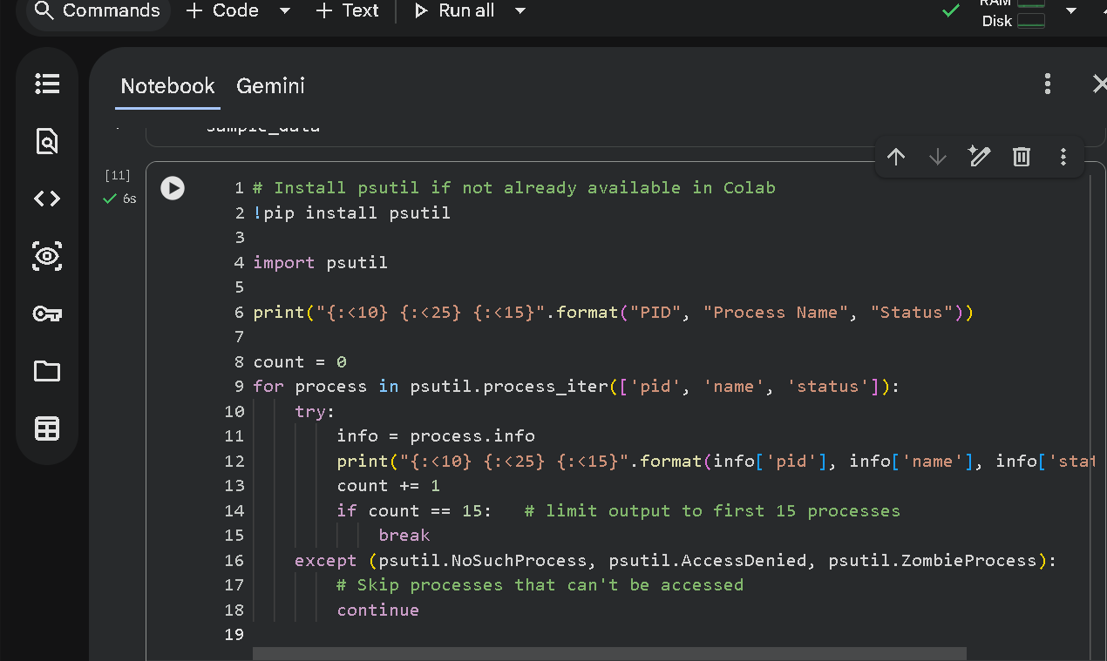
Explanation: This cell imports psutil and loops through the running processes of the Colab VM. For each process it prints the PID, name and status, and it stops after 15 processes. Processes that cannot be accessed are skipped by the try/except block.
Output (pasted)
PID Process Name Status
1 docker-init sleeping
7 node sleeping
21 oom_monitor.sh sleeping
23 run.sh sleeping
24 kernel_manager_proxy sleeping
40 tail sleeping
46 tail sleeping
65 python3 zombie
66 colab-fileshim. sleeping
95 sshd sleeping
111 jupyter-server sleeping
5884 python3 running
5913 language_service sleeping
5924 node sleeping
9665 sleep sleeping

Screenshot Q3(b) - Output of the process list
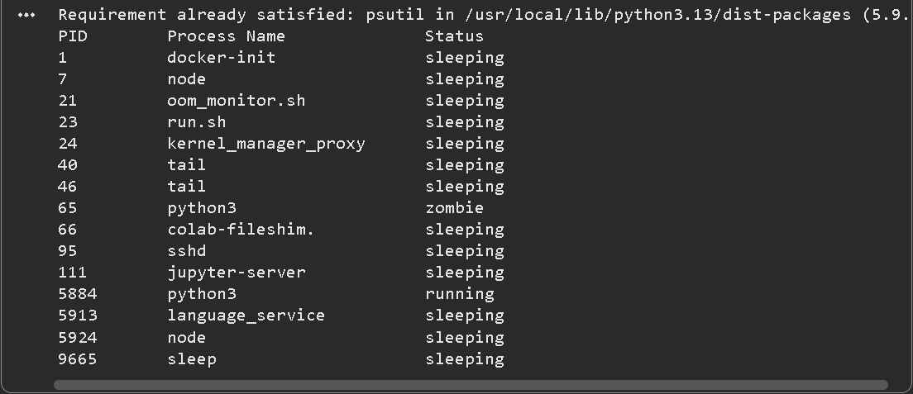
Table of five processes chosen from the output
PID | Process Name | Status
1 | docker-init | sleeping
7 | node | sleeping
95 | sshd | sleeping
111 | jupyter-server | sleeping
5884 | python3 | running

What a PID means: PID stands for Process ID. It is a unique number given by the operating system to every process when it starts, so that the OS can identify, track and control that process. For example, PID 1 (docker-init) is the first process started.
What a process status means: The status tells the current state of a process, that is, what it is doing right now. "running" means it is using the CPU (or is ready to), "sleeping" means it is waiting for something such as input, a timer or data, and "zombie" means it has finished but is still listed until its parent process collects its exit status.
Why so many processes run even when I open few programs: The operating system and the Colab environment start many background processes by themselves. In my output, docker-init, sshd, jupyter-server, node and language_service handle things like the notebook connection, networking and code services. In copy.sh, the ps command also showed many kernel threads (kthreadd, kworker) that keep the system running. Most of these are sleeping and wake up only when needed, so they use very little CPU.

Q4. Process and Thread Thinking Task
1. Would the browser use only one activity internally or many? I would expect many activities. Playing a video, downloading a file and typing in a form all need to happen at the same time. If the browser used only one activity, the video would freeze while the file downloads or typing would lag. So the browser uses several threads (and often several processes, such as one per tab) so each task keeps going without blocking the others.
2. Difference between a process and a thread: A process is a program in execution with its own memory space and resources. A thread is a smaller unit of execution inside a process; the threads of one process share its memory and files, but each has its own steps of execution. In short, a process is the container and threads are the workers inside it.
3. Example where multiple threads make an application more responsive: In a browser, one thread can download a large file in the background while another thread handles the screen, so I can still scroll the page and type in a form without the window freezing.
4. Diagram - one Browser Process containing three threads:
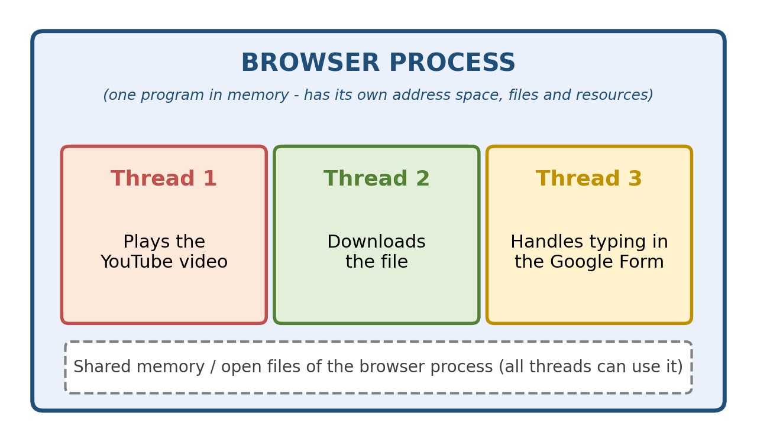

Section C - CPU Scheduling

Q5. Observe CPU activity
Code run in Colab
total = 0
for i in range(1, 80000000):
total += i * i
print("Task completed")

Note: I used 80,000,000 iterations (ten times the sample) so that the loop ran long enough (about 16 seconds) to observe.
Screenshot Q5 - CPU-heavy loop code and output
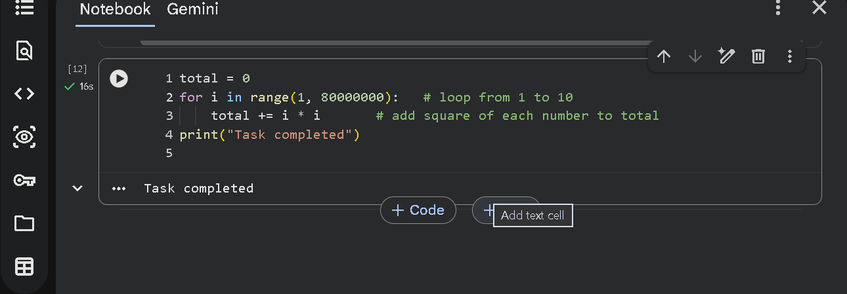
Output: Task completed
CPU usage screenshot: The environment did not provide a visible CPU monitor (only a RAM/Disk indicator was shown at the top right of Colab), so I am not attaching a CPU usage screenshot.
What the CPU is doing while the loop runs: The CPU repeatedly executes instructions for this loop: it takes the next value of i, multiplies i by itself, and adds the result to total. It does this about 80 million times. During this time the Python process stays busy using the CPU continuously, and the OS keeps giving it CPU time until the loop finishes and "Task completed" is printed (about 16 seconds in my run).
What could happen if many CPU-heavy programs request the CPU at the same time: They would have to compete for the same CPU. The OS scheduler would have to share the CPU between them, so each program would take longer to finish, waiting time would increase and the whole system could feel slow or unresponsive. With a poor scheduling method, some processes might even wait a very long time.

Q6. CPU Scheduling Simulation in Python
All processes arrive at time 0. Formulas used: Waiting Time = Start time − Arrival time, Turnaround Time = Completion time − Arrival time.
Process | Burst Time
P1 | 5
P2 | 3
P3 | 8
P4 | 2
Part A - FCFS (order: P1, P2, P3, P4)
Process | Burst | Start | Completion | Waiting Time | Turnaround Time
P1 | 5 | 0 | 5 | 0 | 5
P2 | 3 | 5 | 8 | 5 | 8
P3 | 8 | 8 | 16 | 8 | 16
P4 | 2 | 16 | 18 | 16 | 18

Average Waiting Time (FCFS) = (0 + 5 + 8 + 16) / 4 = 29 / 4 = 7.25 time units
Gantt chart - FCFS
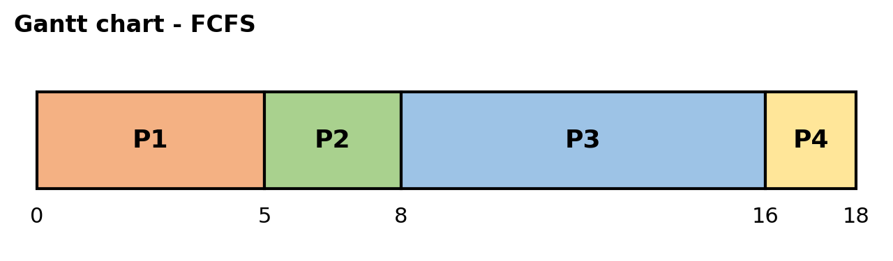
Part B - SJF, non-preemptive (order: P4, P2, P1, P3)
Process | Burst | Start | Completion | Waiting Time | Turnaround Time
P4 | 2 | 0 | 2 | 0 | 2
P2 | 3 | 2 | 5 | 2 | 5
P1 | 5 | 5 | 10 | 5 | 10
P3 | 8 | 10 | 18 | 10 | 18

Average Waiting Time (SJF) = (0 + 2 + 5 + 10) / 4 = 17 / 4 = 4.25 time units
Gantt chart - SJF
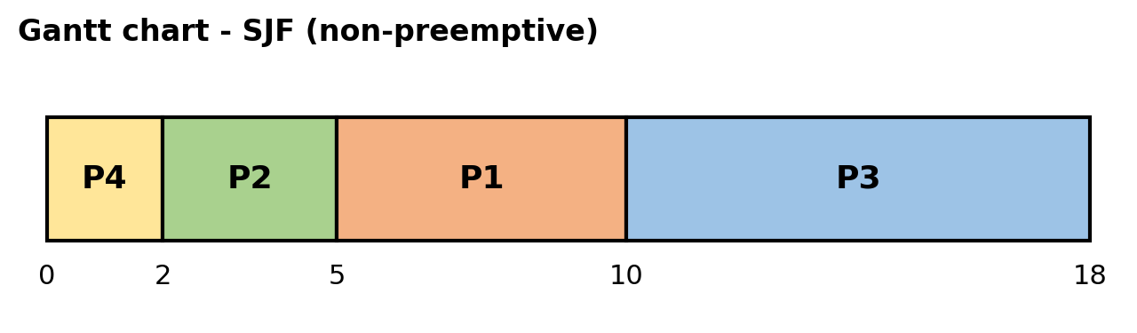
Which algorithm gives the lower average waiting time?
SJF. Calculated result: FCFS = 7.25 and SJF = 4.25 time units. In SJF the short processes (P4 and P2) run first, so they wait very little. In FCFS the short process P4 had to wait 16 units behind the long process P3. Running short jobs first reduces the total waiting time of all the processes, so the average becomes lower.
Optional Python check
processes = [("P1", 5), ("P2", 3), ("P3", 8), ("P4", 2)]

def schedule(order):
time = 0
result = []
for name, burst in order:
waiting = time
time += burst
turnaround = time
result.append((name, burst, waiting, turnaround))
return result

def show(title, result):
print(title)
print("Process Burst Waiting Turnaround")
for name, burst, wt, tat in result:
print(f"{name:<8} {burst:<6} {wt:<8} {tat}")
print("Average Waiting Time =", sum(r[2] for r in result) / len(result))
print("Average Turnaround Time =", sum(r[3] for r in result) / len(result))
print()

fcfs = schedule(processes)
sjf = schedule(sorted(processes, key=lambda p: p[1]))
show("FCFS (P1, P2, P3, P4)", fcfs)
show("SJF (P4, P2, P1, P3)", sjf)

Output (pasted)
FCFS (P1, P2, P3, P4)
Process Burst Waiting Turnaround
P1 5 0 5
P2 3 5 8
P3 8 8 16
P4 2 16 18
Average Waiting Time = 7.25
Average Turnaround Time = 11.75

SJF (P4, P2, P1, P3)
Process Burst Waiting Turnaround
P4 2 0 2
P2 3 2 5
P1 5 5 10
P3 8 10 18
Average Waiting Time = 4.25
Average Turnaround Time = 8.75

[Paste screenshot of this code and its output from Colab here, or delete this optional Python check section]

Q7. Scheduling Decision Task
Case | Choice | Reason
Case 1: Four jobs are waiting and the system simply serves them in the exact order they arrived. | FCFS | First Come, First Served runs jobs strictly in the order of arrival.
Case 2: A time-sharing system gives every active process a small time slice so that no process uses the CPU for too long continuously. | Round Robin | Round Robin gives each process a fixed time slice in turn, so no process can hold the CPU for too long.
Case 3: The scheduler first chooses the job with the smallest CPU burst. | SJF | Shortest Job First always picks the process with the smallest burst time next.

Section D - Reflection & Creative Task

Q8. Design your own "Mini OS Dashboard"
Drawing Q8 - Mini OS Dashboard (drawn using shapes)
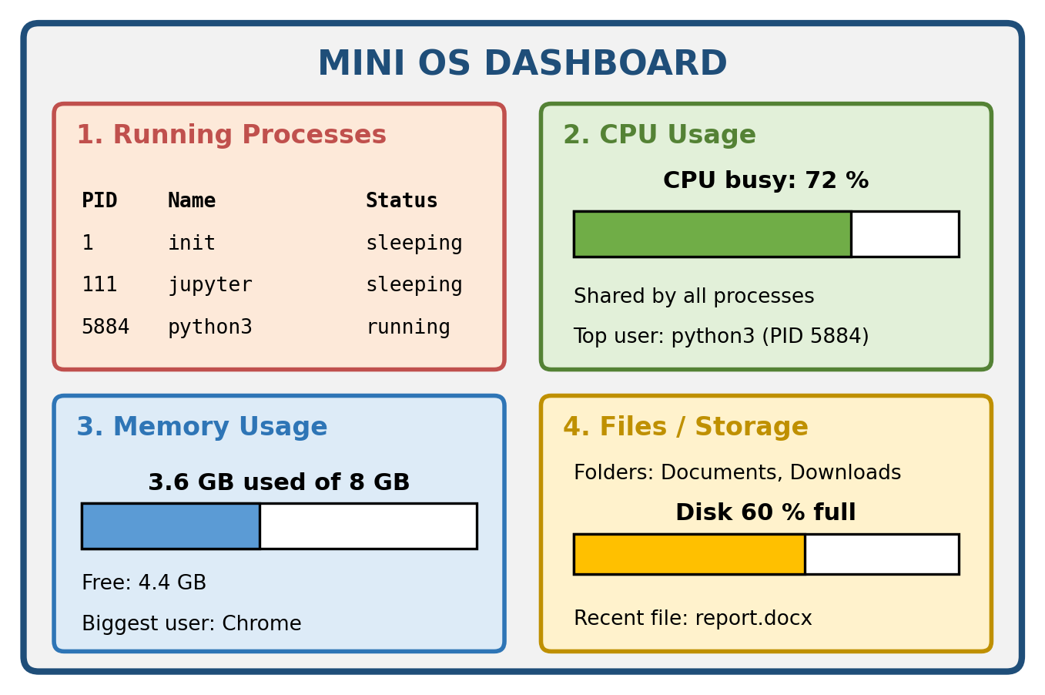
1. Running Processes: Shows the list of active programs with their PID, name and status (running or sleeping), so a beginner can see what the computer is working on.
2. CPU Usage: Shows how much of the CPU is busy right now as a percentage, and which process is using the most.
3. Memory Usage: Shows how much RAM is used and how much is free, and which program uses the most memory.
4. Files / Storage: Shows the main folders, how full the disk is, and recently saved files.
(The numbers in the drawing are sample values only, to show what each box would display.)

Q9. Exit Reflection
- A concept that became clearer: CPU scheduling. Using the same four processes, FCFS gave an average waiting time of 7.25 while SJF gave 4.25, so the order in which the OS runs processes really changes how long they wait.
- A question I still have: A real OS cannot know the burst time of a process in advance, so how does it apply an idea like SJF in practice?
- Processes and CPU scheduling in one sentence: Every running program is a process, and CPU scheduling is how the operating system decides which process gets the CPU next and for how long.

